

Travlr Getaways Web Application

CS 465 Project Software Design Document
Version 2.0

Table of Contents

CS 465 Project Software Design Document 1
Table of Contents 2
Document Revision History 2
Instructions 2
Executive Summary 3
Design Constraints 3
System Architecture View 3
Component Diagram 3
Sequence Diagram 4
Class Diagram 4
API Endpoints 4
The User Interface 4

Document Revision History

Version | Date | Author | Comments
1.0 | 09/20/2026 | Cielo Neal | Completed executive summary, design constraints and system architecture view
2.0 | 10/4/2026 | Cielo Neal | Completed sequence diagram, class diagram, and API endpoints
3.0 | 10/18/226 | Cielo Neal | Completed document

Instructions

Fill in all bracketed information on page one (the cover page), in the Document Revision History table, and below each header. Under each header, remove the bracketed prompt and write your own paragraph response covering the indicated information.

Executive Summary

The Travlr Getaways web application will be built using the MEAN (MongoDB, Express, Angular, Node.js) stack. Node.js will allow the creation of the web server that the entire application will run on. The use of Node.js means that javascript will be used for the entire application, rather than having to use multiple languages. MongoDB is the NoSQL (non-relational database) database management system with will store the static content to be displayed on the site.

On the front end of the application, Express will serve the content, read from the MongoDB database and put through the Handlebars template. Express makes the routing and handling of data simple, fitting well into the MVC (model view controller) architecture the application uses.

The admin side of the web app will use a single page application (SPA) created using Angular. The SPA will allow administrators to accomplish many tasks in a responsive, easy to use environment that is guarded behind user authentication. Updating the content for the client-side site can be done through the SPA with functions that will add and update documents in the MongoDB database.

Design Constraints

This website will be designed with the MEAN stack in mind, meaning development will have to take design best practices in mind. The MVC framework will be used to keep separations of concerns in mind, which will allow elements to be reused and updated without being hard-linked to this application. Similarly, content of the front-facing site must be updateable without redeploying the entire application. The final design must be responsive and provide a good user experience across a multitude of devices. The admin portal should be a well-optimized SPA that dynamically loads and manages components without lag.

In the MEAN stack itself, MongoDB is a flexible and scalable database system but may have performance issues as a data set becomes excessively large. Additionally, there may be compatibility issues with the site itself if data is saved in an inconsistent manner. The implementation of Express, Angular, and Node means that there are a lot of components and potential breakpoints, which may make future maintainability difficult. This could potentially cause concerns when elements have major updates and methods are depreciated.

Sensitive operations such as login and admin functions should be protected using authentication systems like JWT.

System Architecture View

Component Diagram

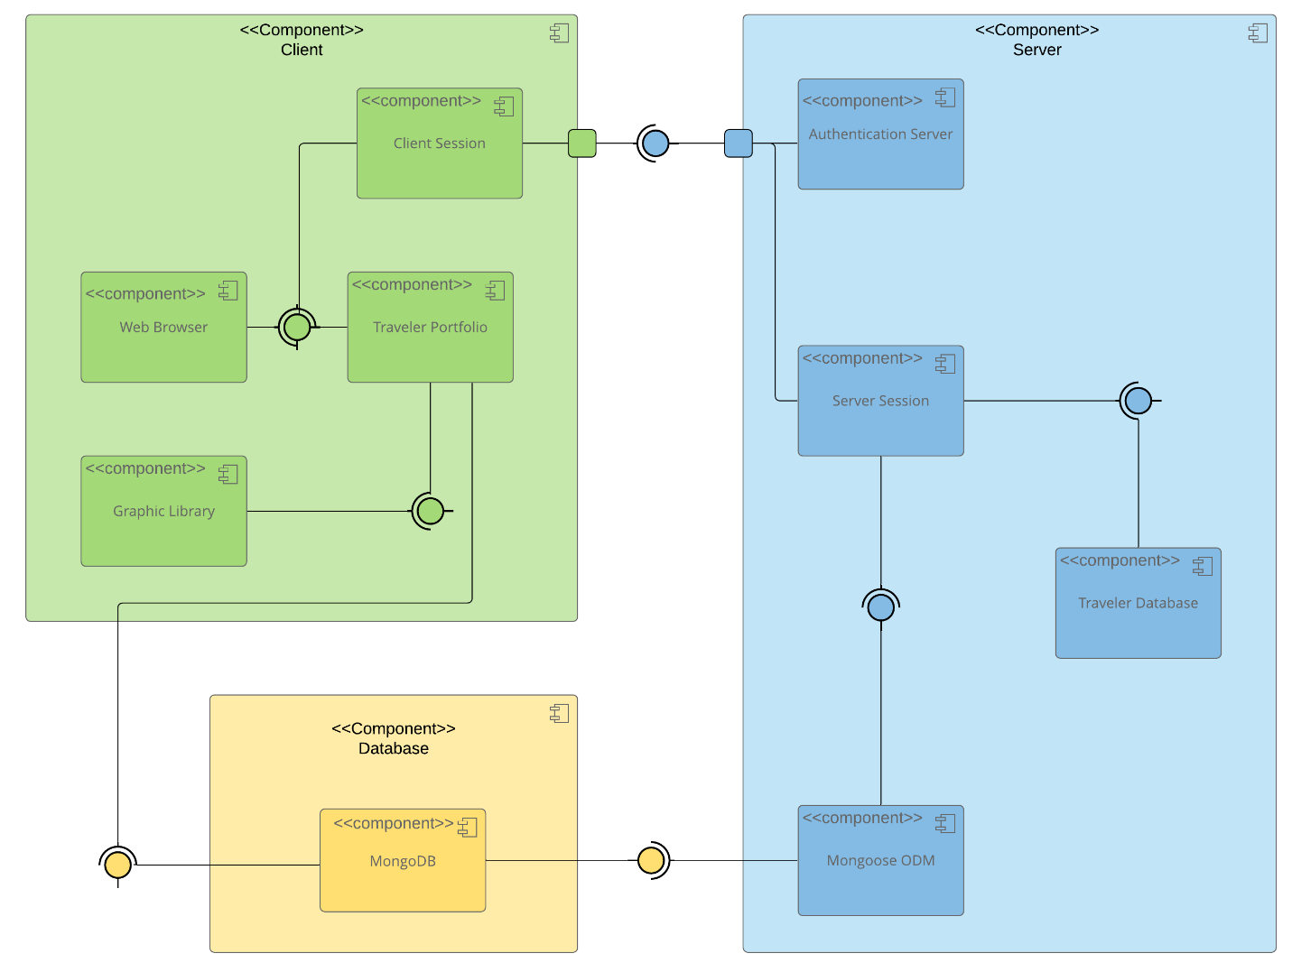

A text version of the component diagram is available: CS 465 Full Stack Component Diagram Text Version.

The application architecture relies on three major components: the client side, the server side, and the database. The client-side component contains the Client Session, Web Browser, Traveler Portfolio and Graphic Library. The web browser and graphic library both provide interfaces. The client session and traveler portfolio both require the web browser interface. The traveler portfolio also requires the graphic library interface and the database interface from the database component. The client session interacts with a port on the client component to connect to the server component interface.

The server-side component contains the Authentication Server, Server Session, Traveler Database, and Mongoose ODM. The traveler database and mongoose ODM both provide interfaces. The server session requires both the traveler database and mongoose ODM interfaces. The mongoose ODM requires an interface from the database component. Both the authentication server and server session connect with a port to provide the client component the required interface.

Finally the database component has the MongoDB part, which provides an interface for both the client and server components.

Sequence Diagram

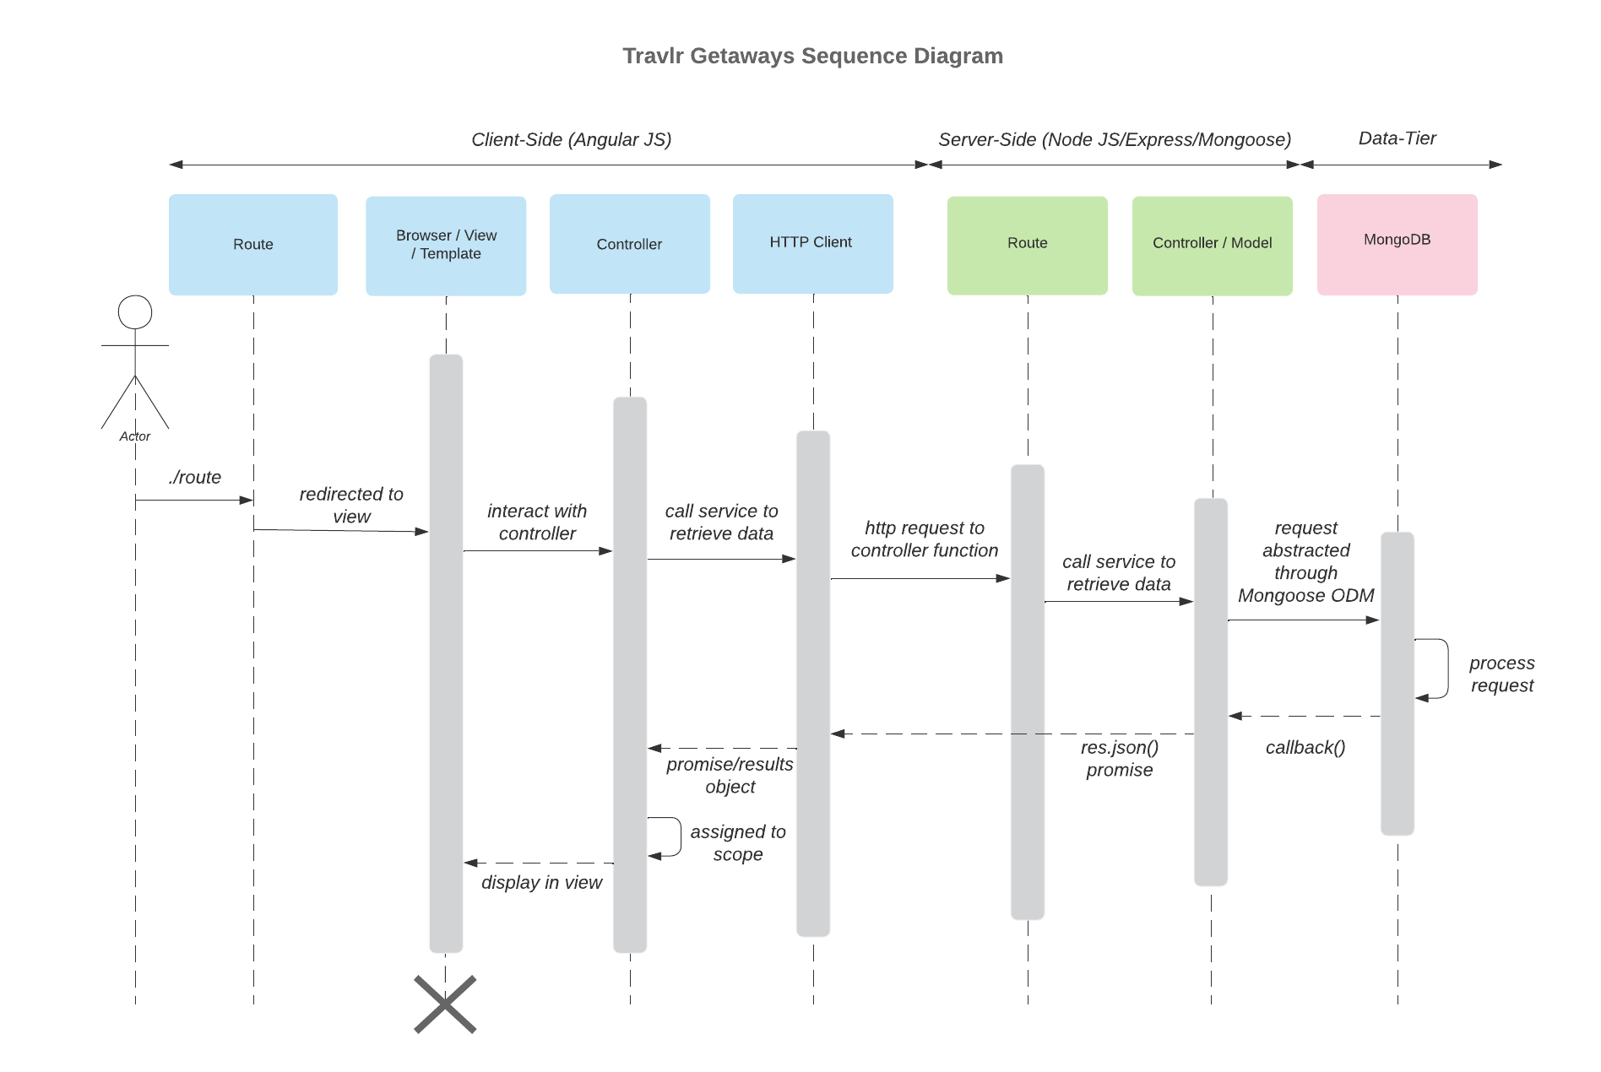
A user enters a route in the browser’s address bar. The browser interprets the route and forwards the request to the appropriate controller. The application’s app.js file defines the available routes, enabling the browser to determine which routes to use and where to locate them. The route directs the browser to the corresponding controller, which retrieves the requested data from the server-side models. The controller then generates an HTML page that includes the requested data and sends it back to the browser for the user to view.

If the browser requests data stored in the database, a second API controller is employed to fetch and deliver this data. For example, if the page needs to display database content, the process begins similarly, with the initial controller handling the request and rendering the basic HTML page. During this rendering process, a call is made to the second API controller, which uses middleware to retrieve the required data. In this case, the middleware “Mongoose” interacts with MongoDB to fetch the data. If data is found, it is returned to the API controller as one or more JSON objects. The API controller forwards this response to the HTTP client, which then passes it along with the HTML content back to the first controller. Finally, the combined data is rendered in the browser for the user.

Class Diagram

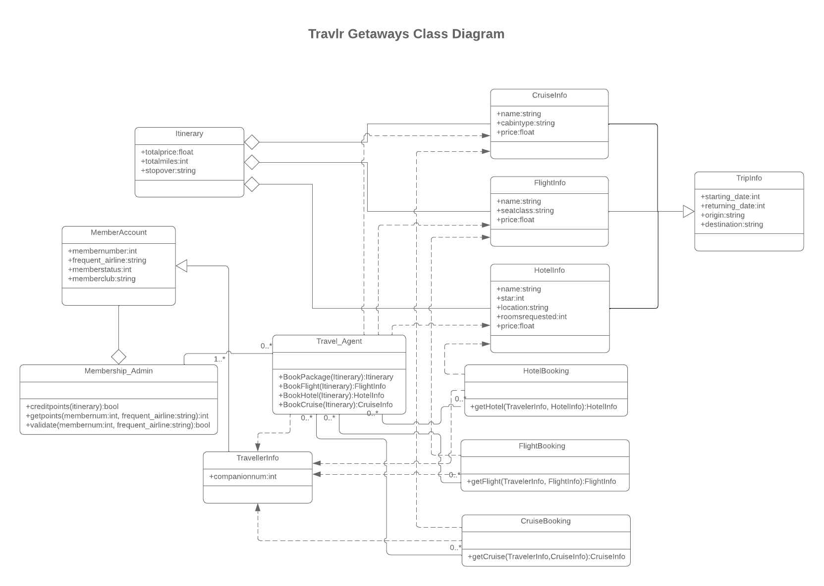
The HotelInfo, FlightInfo, and CruiseInfo classes each contain attributes such as name, price, and specific properties relevant to their respective types of bookings. All three classes inherit from the abstract TripInfo class, which lends them the start date, return date, origin and destination attributes. These classes aggregate into the Itinerary class, which adds the total price and miles for the trip, and includes any stopovers. The HotelBooking, FlightBooking, and CruiseBooking classes include methods for booking their respective components, such as getHotel, getFlight, and getCruise, which pulls information from the matching -Info class. These booking classes interact with the TravellerInfo class and corresponding -Info classes to facilitate booking a trip.
The Travel_Agent class is a central entity which facilitates interactions between various classes. It handles the booking of different trips with the associated itinerary information. The Membership_Admin class aggregates all MemberAccount instances and handles the awarding and getting of member points as well as validating the account itself. Meanwhile the MemberAccount class holds internal details such as the membership number, frequently used airline, the member status and member club. Addtionally, the TravellerInfo class, which inherits from MemberAccount, adds the number of companions for a trip to be used in booking functions.

API Endpoints

Method | Purpose | URL | Notes
POST | Login a user | /api/login | Authenticates a user with email and password
POST | Register a user | /api/register | Add a new user to the database using name, email, and password. Password is saved as a hash function
GET | Retrieve list of trips | /api/trips | Returns all trips
GET | Retrieve single trip | /api/trips/:tripCode | Returns a single trip, identified by the trip code at the end of the URL
POST | Add a trip | /api/trips | Add a new trip to the database
PUT | Update single trip | /api/trips/:tripCode | Updates a single trip, identified by the trip code at the end of the URL

The User Interface

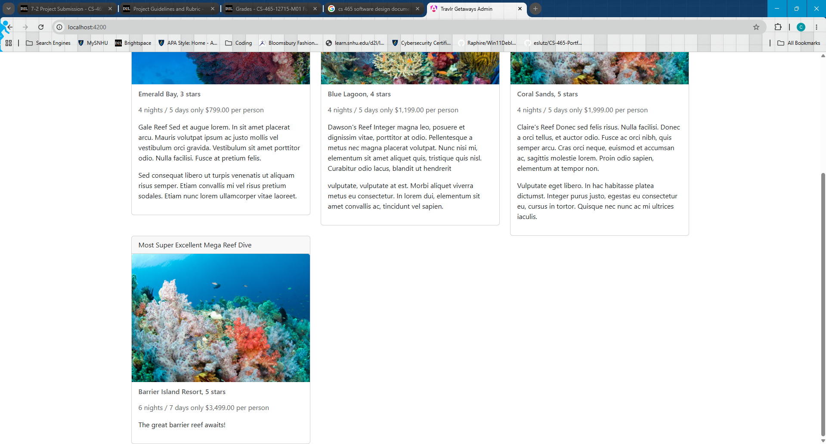
Screenshot of SPA, including a unique trip.

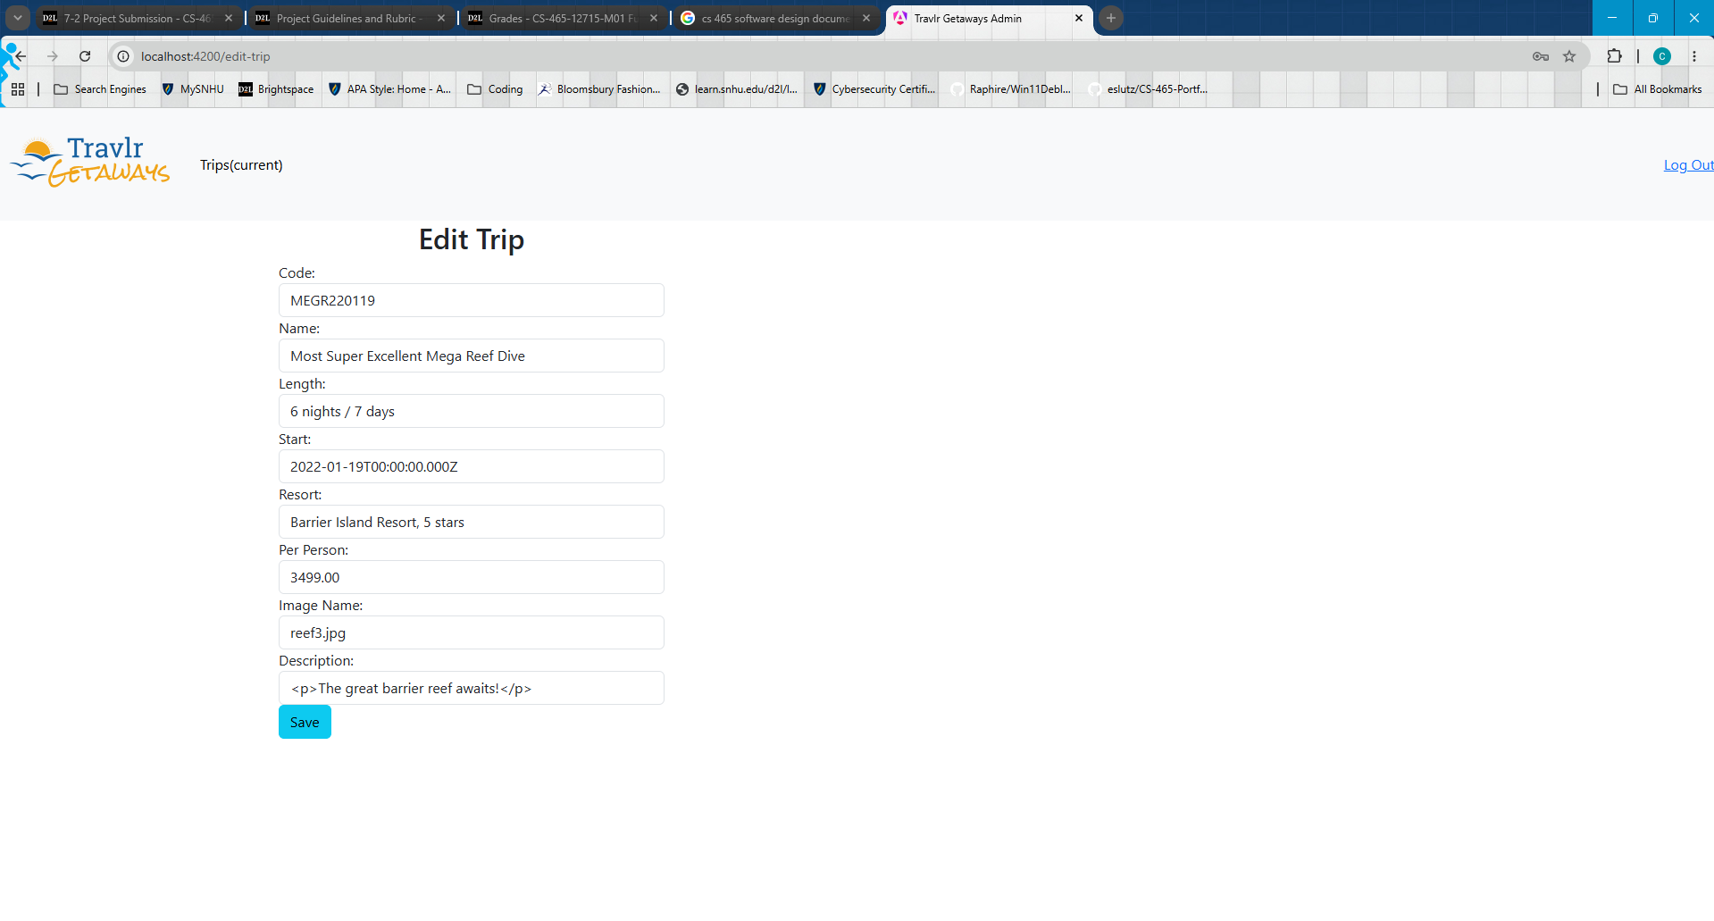
Edit trip form.

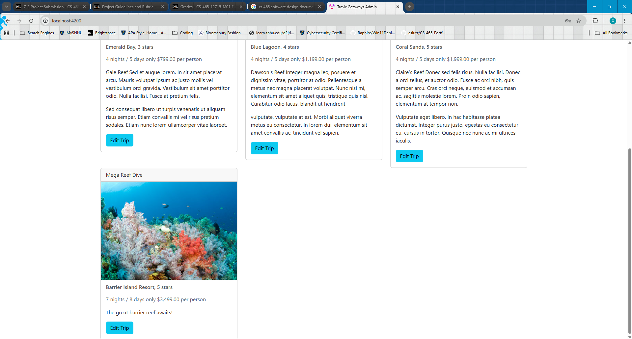
Updated trip with changed name and stay

The Angular framework powers the SPA for the Travlr Getaways administrative interface, which offers a modular and dynamic approach to managing data. Components are easily generated by Angular’s system and routed to backend services, which allow for seamless navigation and real-time updates without full reloads. This allows administrators to have an intuitive experience using the site to add and update trips with instant database updates.

Express.js was used to build the backend, which handles API requests and the MongoDB connection. The efficient backend routing powered by Express allows the Angular frontend to work as smoothly as possible with API calls, authentication, and error handling taken care of through Express.

Compared to traditional web applications, SPAs allow a more dynamic and smooth experience with multiple components and functions available with minimal reloading. This is great for administrative sites which demand snappy functionality and long use-time. Since the administrative side is not public-facing, the fact SPAs are not easily web-scrapped for search engines is a bonus rather than a weakness. Testing SPAs involves making sure all components display as intended and that API calls function as they should. Tools like Postman, which tests API requests, and MongoDB Compass, which displays data stored in the database, are vital for ensuring that key endputs and requests work properly. Additionally, browser developer tools, such as Inspect, help with identifying breakpoints in live service.

